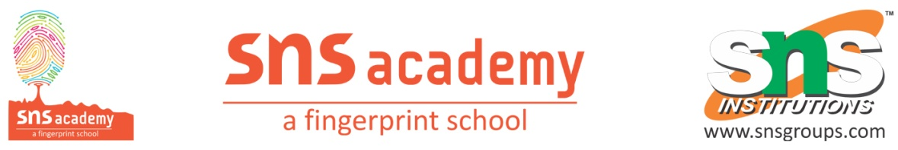
Grade – X
1. CHEMICAL REACTIONS AND EQUATIONS
ANSWER THE FOLLOWING:
1. Write the balanced chemical equations for the following reactions and identify the type of reactions
i) Iron (III) oxide reacts with aluminium and gives molten iron and aluminium oxide.
ii) Ethanol is burnt in air to form carbon-di-oxide, water and releases heat.

2. Identify the reducing agent in the following reactions
a) 4 NH₃ + 5O₂ → 4NO + 6H₂O
b) H₂O + F₂→ HF + HOF
c) H₂ + O₂→ H₂O

3. Identify the oxidizing agent in the following reactions
a) Pb₃O₄ + 8HCl → 3PbCl₂ + Cl₂ + 4H₂O
b) 2Mg + O₂→ 2MgO
c) CuO + H₂→Cu + H₂O

4. A substance X, which is an oxide of a group 2 element, is used intensively in the cement industry. This element is present in bones also. On treatment with water it forms a solution which turns red litmus blue. Identify X and also write the chemical reactions involved.

5. A magnesium ribbon is burnt in oxygen to give a white compound X accompanied by emission of light. If the burning ribbon is now placed in an atmosphere of nitrogen, it continues to burn and forms a compound Y.
a) Write the chemical formulae of X and Y.
b) Write a balanced chemical equation, when X is dissolved in water.

6. On heating blue coloured powder of copper (II) nitrate in a boiling tube, copper oxide, oxygen gas and brown gas X is formed
a) Write a balanced chemical equation of the reaction
b) Identify the brown gas X
c) Identify the type of reaction

7. The following reactions are observed to occur;
a) CuSO₄ + Fe → FeSO₄ + Cu
b) FeSO₄ + Zn→ ZnSO₄ + Fe
c) 2AgNO₃ ₊ Cu → Cu(NO₃)₂ ₊ Ag
Arrange Cu, Fe, Ag, Zn in order of their reactivity.

